Name __________________________________ Date
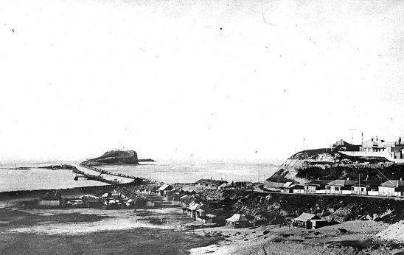
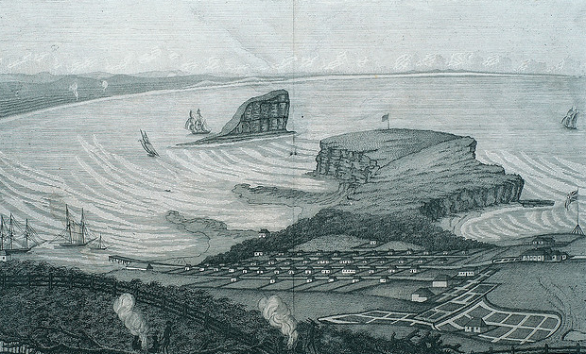
PLACE – PAST AND PRESENT
PICTURE 1 PICTURE 2
What is the name of the island in these pictures?Nobbys Island
Where is it? Newcastle Harbour
Why is it important? History, the first place coal found, a feature of the harbour, etc

Which picture is older? How do you know? The one on the left. The town and ships look older.

What changes can you see between the pictures? Nobbys is smaller in picture 2, the breakwater has been built in picture 2, the town looks bigger with more houses

Why were these changes made?
Newcastle population grew, changes were made to the harbour to make it safer for ships

