Name __________________________________ Date
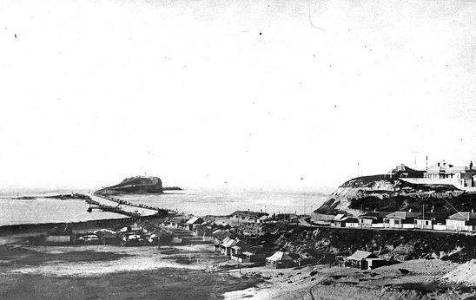
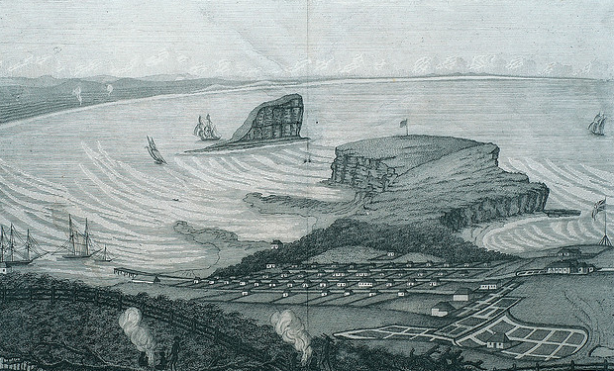
PLACE – PAST AND PRESENT
PICTURE 1 PICTURE 2
What is the name of the island in these pictures?
Where is it?
Why is it important?

Which picture is older? How do you know?

What changes can you see between the pictures?

Why were these changes made?

