Name __________________________________ Date_______________
PLACE – PAST AND PRESENT
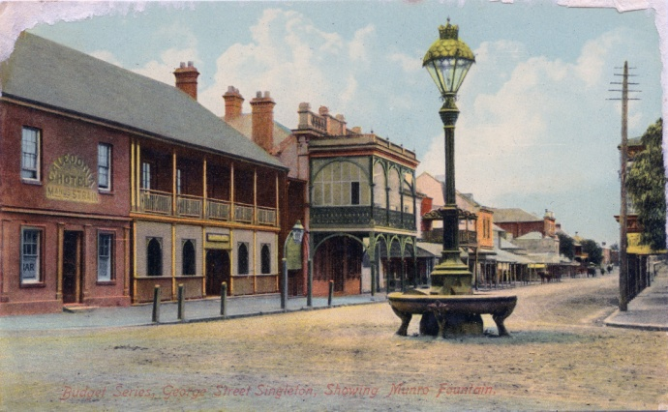
PICTURE 1 PICTURE 2
What is the name of the object in these pictures? Munro Fountain
What was it for?
It allowed people, horses, and dogs to drink after being weary from travel

Which picture is older? How do you know?
Picture 1 – the 2nd picture shows the fountain where it is now, the other must be older
What changes can you see between the pictures?
The fountain has moved from the street to in front of the museum.

Why were these changes made?
When cars became more common in Singleton, the fountain was a traffic hazard. A highway now goes through where the lamp originally stood.

