Name __________________________________ Date_______________
PLACE – PAST AND PRESENT
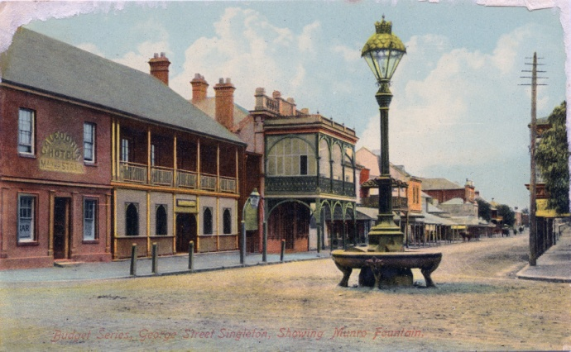
PICTURE 1 PICTURE 2
What is the name of the object in these pictures?
What was it for?

Which picture is older? How do you know?

What changes can you see between the pictures?

Why were these changes made?

