Coal Market worksheet
Look at the slide international Coal exports from NSW 1886 and answer the following”
1 How many of these were British Colonies? __________________________
2 What is Sandwich Islands now called? __________________________
3 Where is Kaiser Wilhelm’s Land? ____________________________
4 What country colonized Kaiser Wilhelm’s Land? ___________________________

5 List the market percentage of the following:
- a Percentage overseas exports 1923 ___________
- b Percentage overseas exports 1928 ___________
- c Percentage overseas exports 2011 ____________

- e Percentage of coal used in Australia 1923 __________
- f Percentage of coal used in Australia 1928 __________
- g Percentage of coal used in Australia 2011 __________
6 Which market was the biggest market in?
- 1923 ___________
- 1928 ___________
- 2011 ___________
7How has the coal market in NSW changed?
______________________________________________________________________________________________________________________________________________________________________________________________________________________________________________________
Look at the pie charts .
8 Who was the biggest user of coal in NSW in 1923? ____________
9 What percentage of coal was used to produce electricity in 1923? _________
10 What percentage of coal was used to produce electricity in 2008-2009? _________
11 What changes in technology have had an effect on the way NSW uses its Energy

12 Use copies of the map on the next page to map countries NSW exported coal to in 1886 & 2010/11

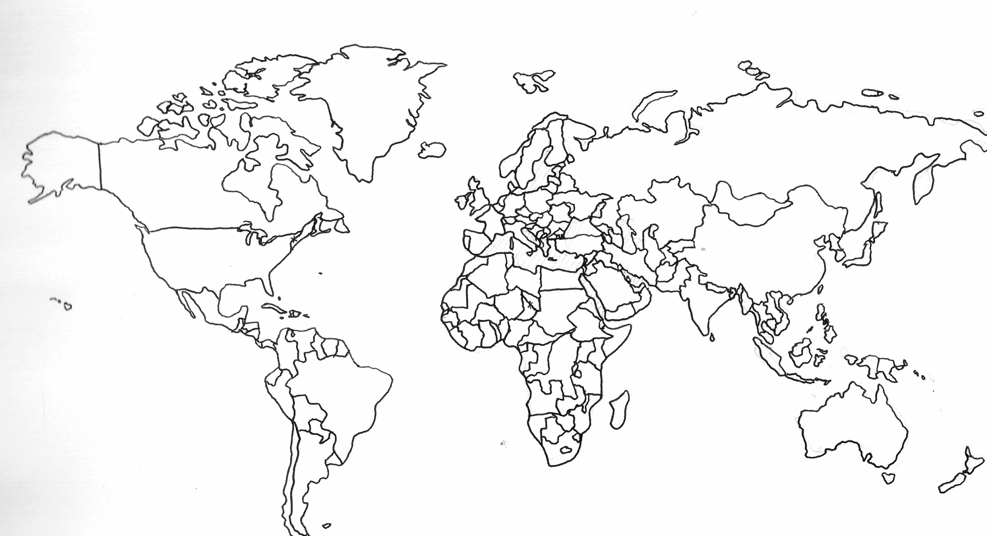
Research
13 From the colonies identified in International Coal exports from 1886

